Successfully Delivery for Photo Sphere to Client in Oct.,2023
How is the photo sphere developed?
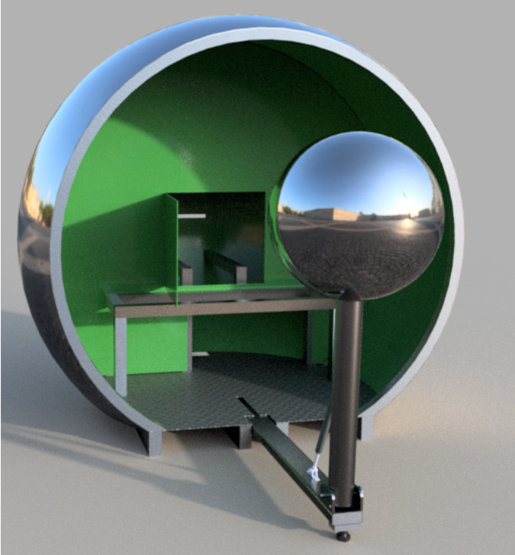

- Firstly, confirm drawing,CNC laser cut the arch frame, prepare it as mold, and hand forge the sphere shell.
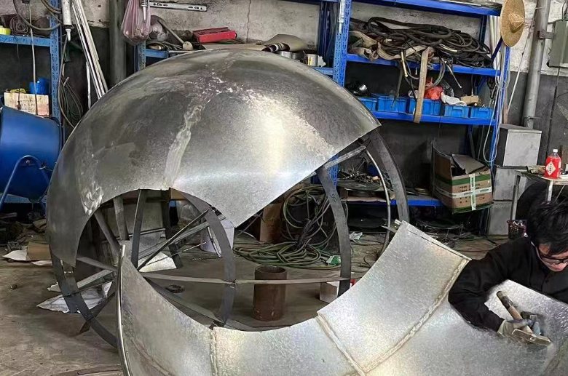
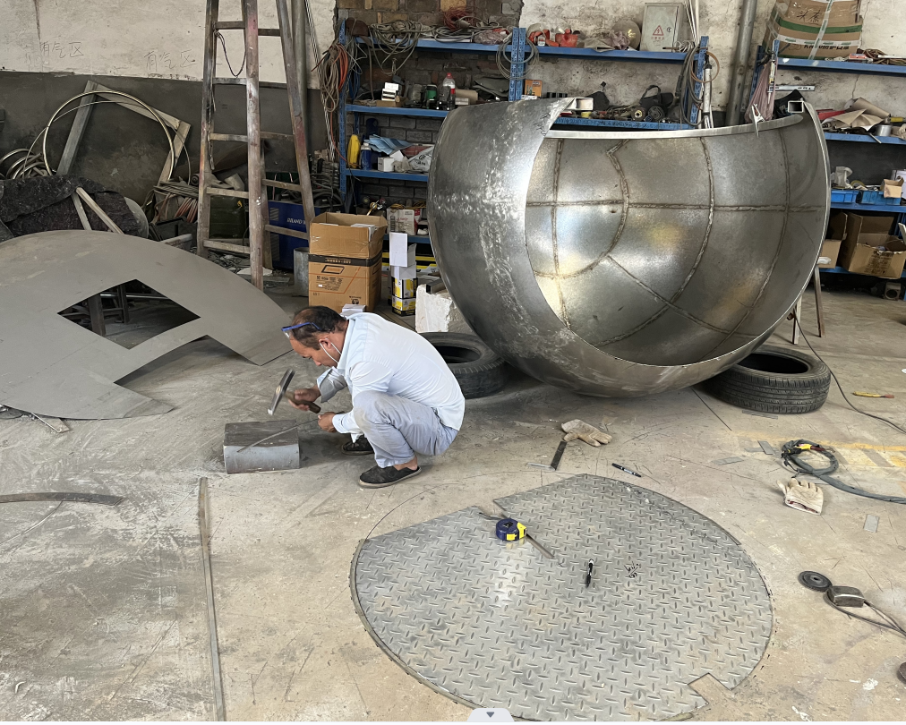

- Assemble parts and polish the edge
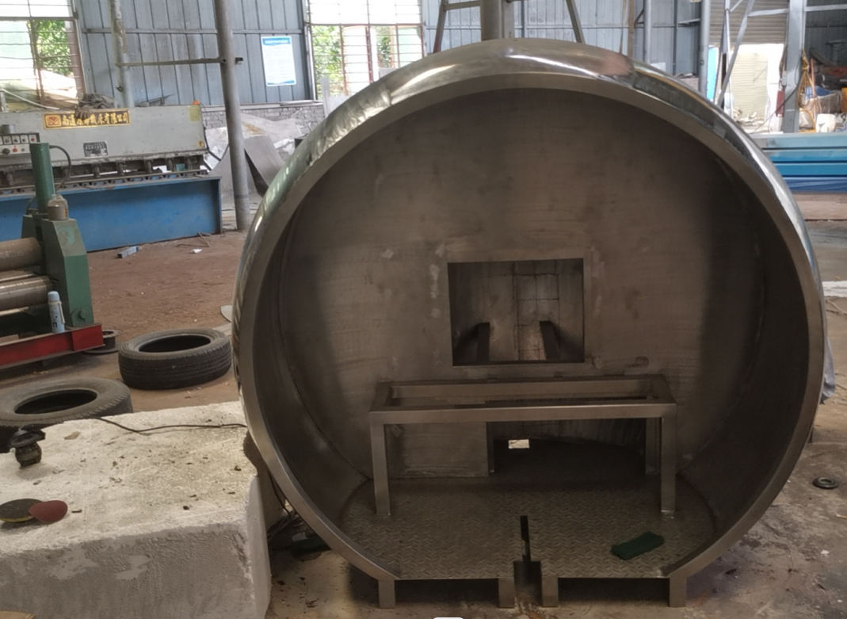
- More polish and assemble rest parts
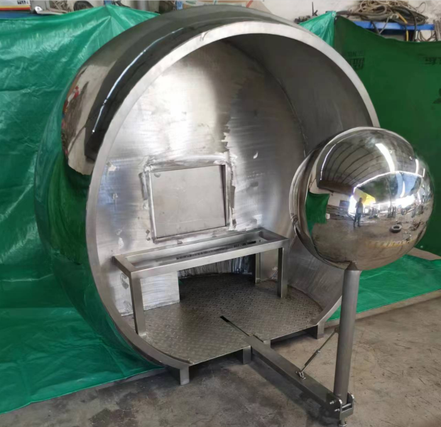
- Make surface finishing
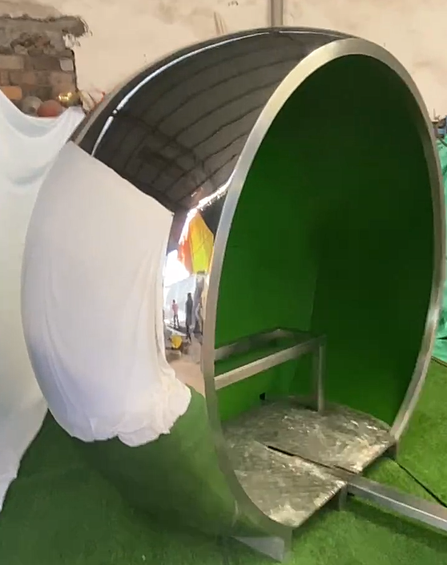 | 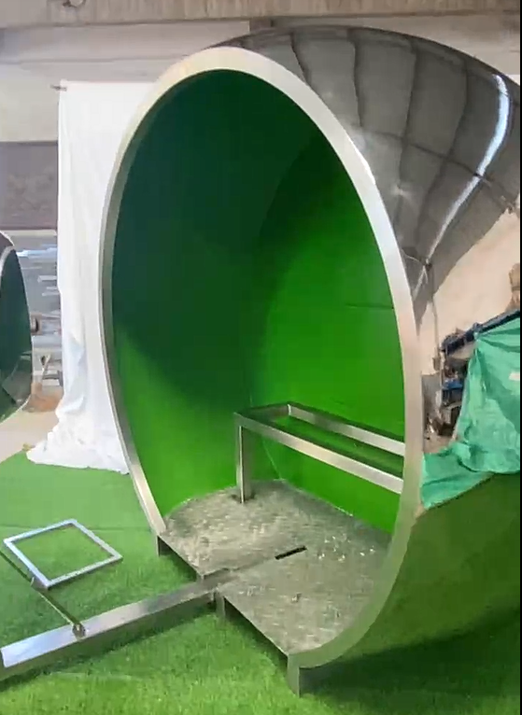

- Make wood carton packing and delivery

